**FACE MASK DETECTOR & TEMPERATURE SENSOR**

**An Engineering Project in Community Service**

**Phase – II Report**

***Submitted by:***

1. Muskan 19BCE10016

2. Dhruv Sharma 19BCE10056

3. Gurdeep Saini 19BCE10347

4. Naitik Gupta 19BCE10398

5. Eshudhi Jangid 19BCE10401

6. Aadya Iyer 19BAI10172

7. Vaishnavi Mahita 19BOE10071

8. Ayush Chaudhary 19BEC10031

***in partial fulfillment of the requirements for the degree of***

***Bachelor of Engineering and Technology***



**VIT Bhopal University, Bhopal**

**Madhya Pradesh**

**24,02,2022**



**Bonafide Certificate**

Certified that this project report titled **“FACE MASK DETECTOR”** is the bonafide work of “ 19BCE10016 MUSKAN, 19BCE10056 Dhruv Sharma, 19BCE10347 Gurdeep Saini, 19BCE10398 Naitik Gupta, 19BCE10401 Eshudhi Jangid, 19BAI10172 Aadya Iyer, 19BOE10071 Vaishnavi Mahita, Ayush Chaudhary 19BEC10031**”** who carried out the project work under my supervision.

This project report (Phase II) is submitted for the Project Viva-Voce examination held on ………

MR. MAYANK GUPTA

**Supervisor**

# **TABLE OF CONTENT**

| S No | Topic | Page No |
| --- | --- | --- |
| 1 | Introduction | 1 |
| 1.1 | Motivation | 1 |
| 1.2 | Objective | 1 |
| 2. | Existing Work/Literature Review | 2-3 |
| 3. | Topic of the work | 4-7 |
| 4. | Impact of our Project | 8-9 |
| 5. | Individual contribution | 10-14 |
| 6. | Performance analysis | 15-17 |

**1. INTRODUCTION**

**1.1 Motivation**

One of the most effective ways to stop the spread of COVID-19 and protect humanity is to practice "prevention is better than cure." Many scientists and physicians are working on corona medication and vaccination.

COVID-19 is primarily spread through droplet infections, which occur when people cough or when we touch someone who is sick and then touch our faces (i.e. rubbing eyes or nose). The current pandemic shows that it is much more contagious and spreads quickly. Infection spread can be classified into two types: rapid spread and slow spread. A rapid pandemic would be disastrous and would claim many lives. It occurs as a result of an infection spreading at a rapid rate due to a lack of countermeasures to slow it down. This is because if the number of infected people grows too large, healthcare systems will become overburdened. We will be short on resources like medical personnel and equipment like a ventilator.

To avoid the scenario described above, we must do everything in our power to turn this into a slow pandemic. Only effective responses, especially in the early stages, can halt the spread of a pandemic. During this period, anyone who is ill can receive treatment, and there is no emergency point with overflowing hospitals.

We must engineer our behavior as a vaccine in the face of this pandemic. "Not becoming infected" and "not infecting others" are two specific goals.

So the incentive behind this project is to detect, measure the temperature and to create a COVID-19 face mask detector.

**1.2 Objective**

1. To detect whether a person is wearing a mask or not. It tracks the people with or without masks in a real-time scenario and ensures social distancing by generating an alarm if there is a violation in the scene or in public places
2. Gives the audio output at all stages Mask, Temperature.
3. To keep people safe from virus transmission.
4. Temperature measurement systems can be rechargeable, portable, cost-effective.

## **2**. **EXISTING WORK/LITERATURE REVIEW**

Today, the use of a personal face mask is a mandatory preventive measure. Keeping the mouth, nose, and cheeks covered has now made people only recognizable by their eyes, eyebrows, and hair, which is a problem for the human eye, which tends to find similarities in several faces that have similar features. The new type of coronavirus is highly infectious. It can be spread through contact, droplets, aerosols and other carriers in the air, and it can survive for 5 days in a suitable environment . The "Guidelines for the Prevention of New Coronavirus Infection Pneumonia" issued by the National Health Commission emphasized that when individuals go out to public places, seek medical treatment and take public transportation, they need to wear medical surgical masks or N95 masks to prevent the spread of the virus. Therefore, it is everyone's responsibility to wear masks in public places during the epidemic, but this requires not only the conscious compliance of the individual, but also the adoption of certain measures to supervise and manage. At present, although there is no algorithm specifically applied to face mask wearing detection, with the development of deep learning in the field of computer vision, neural network-based target detection algorithms are used in pedestrian target detection, face detection, and remote sensing image targets. Detection, medical image detection and natural scene text detection are widely used in fields .

Face recognition algorithms rely on a high degree of recognition accuracy, and have huge application potential in classroom attendance, identity authentication, access control systems, login and unlocking, and social media platforms . At present, face recognition devices on the market have relatively single functions and have relatively high requirements on faces. When the face is in a state of large-area occlusion, the recognition accuracy drops rapidly. Especially in the face of the current epidemic situation where all people wear masks, the capabilities of traditional face recognition systems appear to be stretched. Considering that we will try our best to resume production and work while ensuring people's safety, we have designed a smart detection and recognition system for mask wearing. The system is mainly composed of a face mask detection algorithm and face recognition algorithm. The main functions of the system can be divided into two parts: face mask detection and scanning body temperature. When multiple pedestrians pass by the camera, the camera equipped with this algorithm will first detect the pedestrian's face mask.

When the pedestrian wears the mask normally, it will not give a voice prompt. When a pedestrian wears a mask incorrectly and the body temperature which should be in between 33 - 39 degree celcius to pass the scan. When a pedestrian is not wearing a mask, the system will trigger the face recognition module to remind him to wear a mask. The system can be used in high-speed rail stations, subways, shopping malls and other crowded areas.

Through researching related target detection algorithms, it is found that the deep learning model used for face detection can be applied to the task of mask wearing detection. In this paper, the more accurate face detection algorithm RETINA FACE is used as the basic algorithm for mask face detection, and on this basis, the network structure of the RETINAFACE algorithm is improved, and the attention mechanism is introduced to meet the needs of new functions; In this system, we calculate the mask and the key point positions of the face, and the confidence that the

a mask worn on different faces is returned to determine whether the person wears the mask in a standard manner. The calculation is fast and accurate, and the algorithm is stable and efficient; for the current popular ones For the face recognition method, we use the DEEP FACE algorithm. The algorithm divides the face recognition problem into several related subproblems.

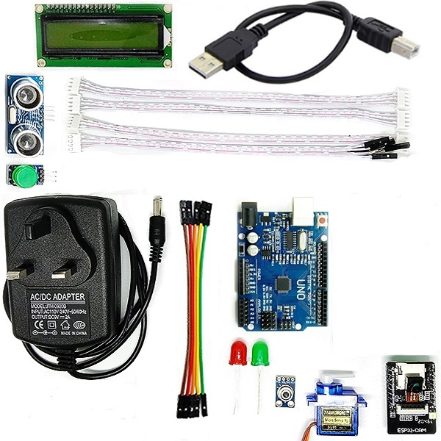

Figure 2.1

(Hardware/Components- LCD Display, ultrasonic sensor, jumper wire, push-button, temperature sensor, esp32 cam, green led, red led, Arduino uno , adapter)

**3. TOPIC OF THE WORK**

**3.1 System Design / Architecture**

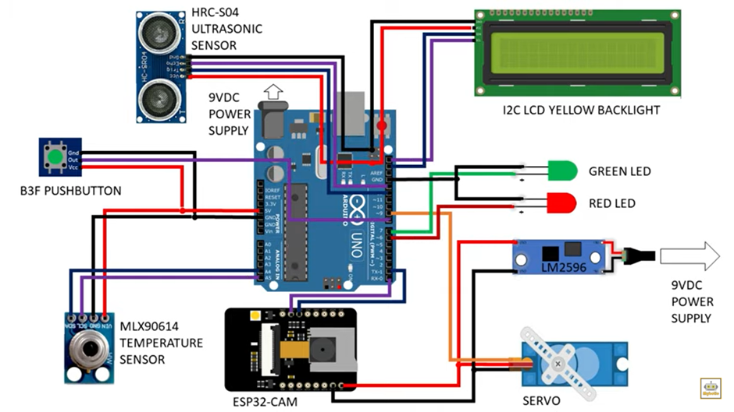

Figure 3.1

( Circuit Diagram )

After face scanning the person using the camera sensor and temperature scanning using the MLX90614 temperature sensor processing of both these data are being done then checked using the code where we have set the threshold values. For the temperature sensor the value being set in the range 32 – 38 degree Celsius and face should be 80 percent covered. If both these conditions get fulfilled then the next conditions in the software code gets executed which is basically we make the green led light ON indicating the person doesn't have high temperature which is basically a sign that the person is having good body temperature and he is having a mask on his face. Along with the green LED light getting ON the code additionally shows 2 statements on the LCD display. The person can go ahead as the entry is now open.

If any one of the conditions or both the conditions fail which is either the person is having high temperature measured under temperature sensor or the mask on the face is not visible then the code will not let the person in on the entry and along with it the red LED light will be ON and LCD will display the temperature using the sensor and if the mask is not covered fully or if it is covered partially it will also be displayed as message in the LCD Display.

**3.2 Working Principle**

Steps for Face Classification -

**1.** **Scanning -**

The working principle starts with firstly scanning of face with the ESP32 CAM sensor which scans whether the face is covered or not with a mask, secondly along with face we scan temperature of the body and if both conditions are under the threshold value then we execute the next statement of software code.

#### **2.** **Processing –**

Next, as the hardware components send the signal, basically the data for the software code. The code checks with the data it gets from the components and executes the following statements accordingly. If both the values are under the threshold value the statements under that condition are good to go and then the software code sends the signal to the hardware components associated with the statements and the components execute their function accordingly.

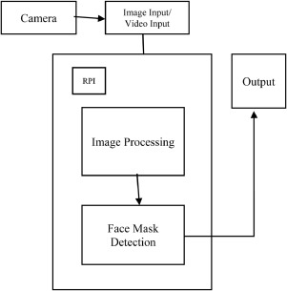

Figure 3.2 (Flow Diagram)

#### **3.** **Executing –**

At Last, as the hardware components get the signal they get accordingly to the software i.e. if the conditions in scanning phase are both under threshold value then the hardware component green LED gets ON along with the entry for the user to get in using the motor component attached with the system through Arduino board along with the LCD Display showing some message which is being coded in the software code for it and if the conditions are not fulfilled then the red LED gets ON and the motor component attached with the system through Arduino board does not get a signal so the user permission to go also gets denied automatically.

**3.3 Expected Results**

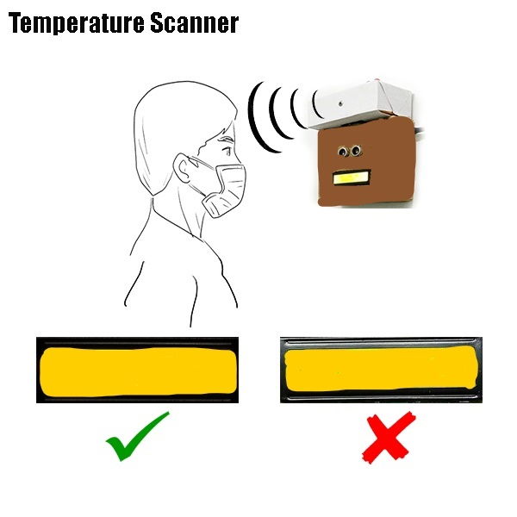

Figure 3.3

(When a person has covered his face with a mask and has temperature under threshold range green led will glow means the person can go and when a person has not got his face covered 80% with mask or if his/her temperature is beyond the threshold range then the red led will glow and the person will not be allowed to go)



Figure 3.4

(Small video of how the system checks the person and let it go)

**4. IMPACT OF OUR PROJECT -**

COVID-19 is a global pandemic and it affects several domains .The next COVID wave is likely to strike the country in another 2 to 3 months in case a new coronavirus variant arrives, as said by the COVID task force official. We can get COVID-19 more than once. We're seeing more re-infections now than during the start of the pandemic. So, all over the world, governments are struggling against this type of virus.

Protection against coronavirus is a mandatory counter measure, according to theWHO . Wearing a mask is an effective method of blocking 80 of all respiratory infections. Properly fitted masks can help prevent the spread of the virus from the person wearing the mask to others. It covers your mouth while coughing and sneezing. Many organizations enforce face mask rules for personal protection. Checking manually if individuals entering an organization are wearing masks is cumbersome and possibly conflicting.

The present scenario of COVID-19 demands an efficient face mask detection application. Our project consists of a sensor MLX90614. It senses the temperature contactless rather than any need of a contact to read temperature. Your body temperature should be between 33 - 39 degree celcius to pass the scan. After passing the temperature scan, you need to scan your face. Camera used is ESP32 which can be controlled wirelessly. You need to stand between 35-60cm from the camera. If not, the camera will not scan your face and ask you to come closer or take a step back. A person needs to pass the threshold value, which is 80% of your face covered to pass the scan. The main goal of our project is to implement this system at entrances of colleges, airports, hospitals, and offices where the chances of spread of COVID-19 through one person to another are relatively higher.

**5. Individual Contribution**

When we first began working as a collective none of us were very sure about how to proceed, we knew that for this to work, everyone would need to take their role within the group, but the problem was in finding what those roles should be. As a group, everyone’s input was needed throughout the process.

In the beginning stages, we all took on very similar working roles. This allowed us to know exactly what other members of the group would be bringing to the next meeting, and so we were able to structure our own work around this knowledge.

1. Vaishnavi Mahita (19BOE10071)-

My contribution to the project involves the research for the materials that can be used.The materials that can be used for face mask detection were the first thing that needed to be done for the project. Using proper materials that can fit the device is the main thing. As a part of my research, I went and looked for the same. The things that were needed for the project is first, a temperature sensor to sense the temperature was required for this project. Second, a camera to determine whether or not a person is wearing a mask. Third, we need a platform to connect everything. I looked for all of these that would work best with this gadget.

According to my study, the MLX90614 temperature sensor is the greatest fit for this. We used this sensor because it is using infrared to read temperature which is suitable for the project. It senses temperature without the need for human interaction to read the temperature. In this project, your body temperature should be between 33 - 39 degree celcius to pass the scan.

The camera in consideration is an ESP32 camera that can be controlled wirelessly. This camera will help to distinguish whether the person is wearing a mask or not. A person needs to stand between 35-60cm from the camera to scan your face. If not, the camera will not scan your face and ask you to come closer or take a step back.

Arduino is a platform that allows us to link all of these things. This is capable of reading all of the inputs. Hence, these were the materials that were used. This is how I contributed to this project.

2. Eshudhi Jangid(19BCE10401)-

My role in the making of this project was precisely to research and design the components of the system. During this, I went through various sensors and detectors and we used the most suitable one according to our requirement. For the mask detector, I researched for the appropriate camera and what we are using here is ESP-32 CAM.

We have used Arduino uno for creating this project which is a great open source software used widely.

Next, for the temperature sensor, We are using MLX90614 Temperature Sensor because here we need to use infrared to read temperature and the MLX90614 sensor is more suitable for this purpose than any other temperature sensor and it is a high-accuracy, non-contact temperature sensor with a broad measuring range that can be used to determine room temperature or the temperature of a specific object.

As I am keenly interested in designing, I also contributed to the project by designing after finding the appropriate components for the project. The research process was very enlightening and helped me to get advanced details of certain modules. Designing as always was very fun and allowed me to expand and implement my vision of creativity.

3. Muskan (19BCE10016) -

My contribution to the project involves working with temperature sensors.

One of the major aspects of our project was to detect the users from COVID 19 by enabling the body temperature assessment. As a part of my research, I went ahead and looked into Multi-temperature sensors so that the body temperature of the individual is monitored using a non-contact temperature sensor. I went out and looked for an appropriate temperature sensor that can be compatible with the Arduino.

Then, we decided to work with the MLX90614 family which is an Infra-Red thermometer for non-contact temperature measurements. Then my next step was to learn about the pins and the internal workings. This temperature sensor is available in 2 supply voltage options: 5V compatible or 3V (battery) compatible along with 2 chips, the Infra-Red thermopile detector, and the signal conditioning, specially designed to process the output of the IR sensor. So, the temperature monitoring system is responsible for analyzing temperature and producing audio output.

The next part was to do the feature extraction of the pins and uncovered that the MLX90614 temperature sensor is connected to the RPi's GPIO Pin. After doing all the research work I went ahead with the code of the sensor and finally exported the result i.e Output is in Celsius, and if the temperature reaches the standard alarm is given as a warning. In this way, I contributed to the working of this module. Along with this I also helped my teammates with the documentation.

4. Dhruv Sharma (19BCE10056) -

As our project involves the detection of face mask it was my role to find the most suitable and least expensive camera for the project which will be compatible.

To prevent COVID 19 it is very important to wear a face mask. So, just after passing the temperature scan the person needs to scan their face.

For the face scan we went through different discussions and research. Finally I came with some simple conditions which need to be fulfilled by the person to pass the scan.The conditions included that the person needs to stand between 35-60cm from the camera to scan his/her face.

A threshold value was very important which would define how much part of the face should be covered by the mask .Threshold value was set to make sure that every person wears his/her mask properly. A person needs to pass the threshold value, which is 80% of the face covered to pass the scan.

The camera which I found most suitable was ESP32-CAM. It is an appropriate camera which is very compatible with Arduino. Arduino is a platform that allows us to link our temperature sensor and camera. It is a small size low power consumption camera. It has a 2 MP sensor, image transfer rate of 15 to 60 fps and a built-in flash LED and we can use it for wireless video monitoring, Wifi image upload and QR identification etc.

The installation and programming of the ESP32-CAM is the major role which I handled.

I used the Board Manager to add the ESP-32 boards so that I can use the ESP32-CAM with Arduino IDE. It was done by adding a JSON file link with Arduino IDE. I modified the sketch as for Select Camera Model I used the *CAMERA_MODEL_AI_THINKER* entry for our board. Then I entered the network access password and loaded the Camera Web Server sketch. The sketch turns the ESP32-CAM into a full-featured online camera, complete with face detection capabilities and different controls.

This is how I contributed to the working of this module.

5. Ayush Chaudhary (19BEC10031)-

We wanted to create something that would benefit people during this covid-19 time as well as developing a model that helped our society in different fields like school, colleges, and shopping malls.

One of the major aspects of our project was model designing so I researched various types of design model’s models like which make your project more productive. Cheaper in rate and easy to execute.

I designed a single compatible model in which all hardware will fit in the proper manner, so that the user of the product can operate it easily.

I contributed to the project by doing research on the existing work of our project idea. I tried to figure out the advantages, and loopholes in the existing work and helped my team members in suggesting some ideas which provided our project an edge. I helped team members by providing them with required references wherever they needed help, and researched, choosing the right level of abstraction for our model as our aim was to build a state-of-the-art model without sacrificing speed or performance.

6. Naitik Gupta (19BCE10398)-

My contribution to the project is to build a system architecture module and after that the actual whole module so that we can take our project closer to our goal. I started by studying different methodologies which are used for face mask and temperature detection. I learned how Arduino takes input by a sensor or machine. Then my next step was to learn about the pins of every sensor and Arduino. After doing all this work, I tried to start working on implementation.

My main contribution to this project is collecting the hardware and connecting them according to the architecture, collecting the source code from the fellow mate and uploading it to the system and running the test cases and arranging all the hardware in a proper manner, and making a single system. I also helped with specific tasks and blocks concerning my area of expertise throughout the project, to assist the team in reaching project goals. The final part of a project is documentation as it presents the whole project simply and clearly, so I also worked towards the documentation for the project.

7. Gurdeep Saini(19BCE10347) -

My contribution to the project involves working with the software code for the Arduino board.

One of the major aspects of our project is to use sensors which get connected to Arduino UNO and to write software code for all sensors and combining them to get a full fetch working code for Arduino IDE was part of my research in the project.

I went ahead and looked for Arduino libraries which will be compatible for the implementation with the idea of the project.

For different project modules I went out and researched appropriate libraries for sensors that can be compatible with the Arduino UNO board.

I read existing work related to our project and using that approach I implemented the code in Arduino IDE for different sensors.

The first thing I went ahead with was to study and read the documents related to the Arduino IDE to get the idea of its syntax which eventually helped me in writing the sensor declaration and the functions required for the sensors to work.

I contributed to the working of this module. Along with this I also helped my teammates in the documentation. This is how I volunteered myself to help my team members in making a successful project. The effort was appreciated and the project will eventually be completed on time.

8. Aadya Iyer (19BAI10172)-

My contribution to the project involves working with motors.

One of the major aspects of our project was to see which motor can be used. As a part of my research, I went ahead and looked into servo motors. I went out and looked for an appropriate servo motor that can be used.

We decided to work with the servo motor which is a control system that acts according to the instructions. Then my next step was to learn about it in detail. It can compare the actual state of the system with the corresponding state of the instructions, and use the comparison result for further control. Servo motors include direct current motors and alternating current motors. The function of the servo motor is to convert the control signal of the controller into the rotational angular displacement or angular velocity of the motor output shaft. Generally, servo motors used in robots should have the following characteristics: fast response speed, high starting torque, wide speed range, etc. When used in a collaborative robot, the servo motor should have the characteristics of small size, lightweight, and hollow structure to achieve safe human–robot collaboration.

In our project if the conditions in scanning phase are both under threshold value then the hardware component green LED gets ON along with the entry for the user to get in using the motor component attached with the system through Arduino board along with the LCD Display showing some message which is being coded in the software code for it. In this way, I contributed to the working of this module.

**6. Performance Analysis**

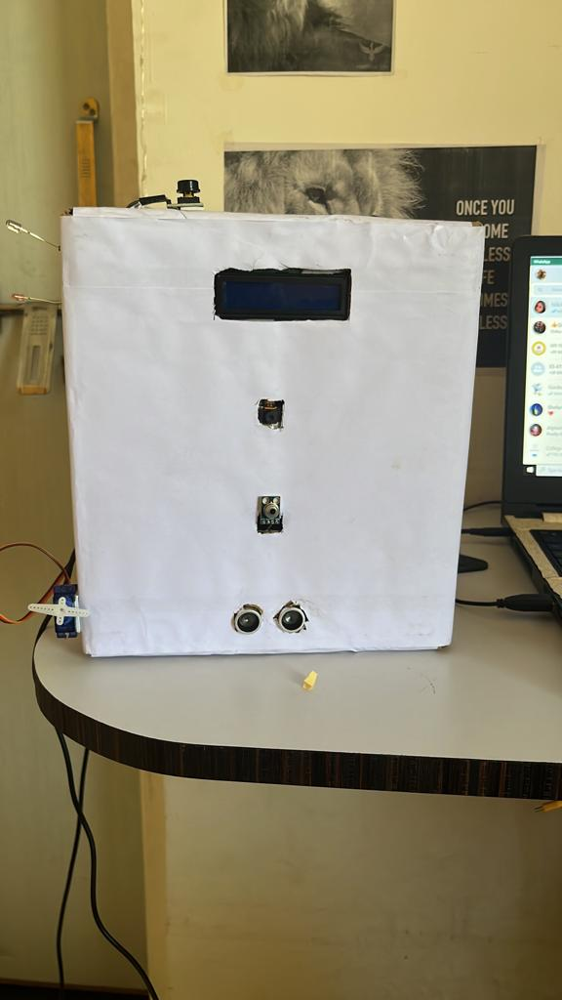

Figure 6.1

(Outer View of The Model )

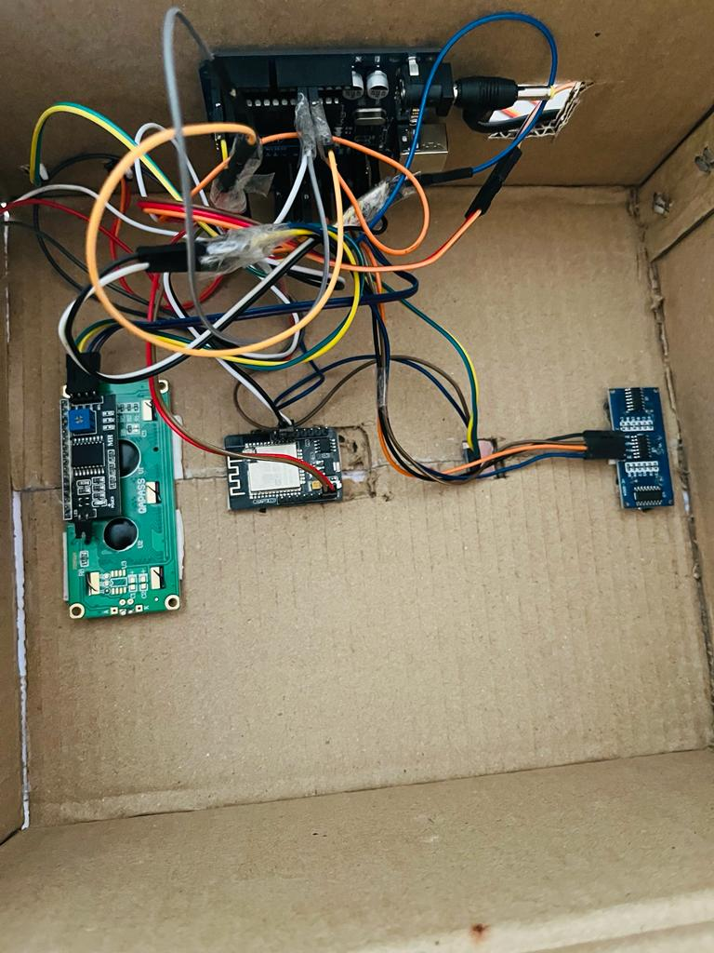

Figure 6.2

(Internal View of the Model)

**7.1 Performance Measures**

We have set the threshold value of a face mask detector as 80 percent means if the face is being covered 80 percent then it can be allowed. Otherwise if the face is not covered with 80 percent then the lcd display will show the message implemented in the code.

Along with setting range for face mask detector we also set range for temperature sensor with the threshold range in between 39 to 35 degree celsius.If the temperature of the person is outside the range then the further code will not get executed and rather the red light will glow with a message.

**7. Conclusion**

We can see that the approach presented here for face detection and tracking decreases the

computation time producing results with high accuracy. Tracking of a face in a video sequence is done using the KLT algorithm whereas Viola Jones is used for detecting facial features. Not only in video sequences, it has also been tested on live video using a webcam. Using this system many security and surveillance systems can be developed and required objects can be traced down easily.

In the coming days these algorithms can be used to detect a particular object rather than faces.

The main purpose of this project is to automate the manual work of the covid-19 protocols and to ensure if people wear masks or not. In this work, we thought of constructing a face mask detection system to detect and capture the temperature of a specific point and also learned how to create a COVID-19 face mask detector using Tensor Flow, Arduino.

This helped to detect and classify the people wearing masks and people not wearing masks. From the experiment, it seems that the real time face-detection system has a high accuracy in detecting masks, this helps to control the spreading of COVID-19 in public places by preventing people from entering it without wearing a face mask.

**8. References**

* Safa Teboulbi, Seifeddine Messaoud, Mohamed Ali Hajjaji, Abdellatif Mtibaa, "Real-Time Implementation of AI-Based Face Mask Detection and Social Distancing Measuring System for COVID-19 Prevention", vol. 2021, Article ID 8340779, 2021. <https://doi.org/10.1155/2021/8340779>
* Real-Time Face Mask Detection and Thermal Screening with Audio Response for COVID-19 M. Sivasankara Rao1*; K. Tejasree2; P. Sathwik3; P. Sandeep Kumar4; M. Sailohith5 1*Sr. Assistant Professor, Department of ECE, Lakireddy Bali Reddy College of Engineering, Mylavaram, India.
* Deep Learning Implementation of Facemask and Physical Distancing Detection with Alarm Systems, Sammy V. Militante; Nanette V. Dionisio, 2020 Third International Conference on Vocational Education and Electrical Engineering (ICVEE). Doi:10.1109/ICVEE50212.2020.9243183
* SSDMNV2: A real-time DNN-based face mask detection system using single shot multibox detector and MobileNetV2 Preeti Nagrath, Rachna Jain, Agam Madan, Rohan Arora, Piyush Kataria, Jude Hemanth.
* A. Rosebrock, "COVID-19: Face Mask Detector with OpenCV, Keras/TensorFlow, and Deep Learning”, May 4, 2020, <https://www.pyimagesearch.com/2020/05/04/covid-19-face-mask-detector-with-opencv-keras-tensorflow-and-deep-learning/>.
* A. Hidayat, Subono, V.A. Wardhany, A.S. Nugroho, S. Hakim, M. Jhoswanda, “Designing IoT-Based Independent Pulse Oximetry Kit as an Early Detection Tool for Covid-19 Symptoms “, 2020 3rd International Conference on Computer and Informatics Engineering (IC2IE).
* K Baskaran, Baskaran P., N. Kumaratharan, Rajaram V., “IoT Based COVID Preventive System for Work Environment”, the Fourth International Conference on I-SMAC (IoT in Social, Mobile, Analytics, and Cloud) (I-SMAC) IEEE Xplore Part Number: CFP20OSV-ART; ISBN: 978-1-7281-5464-0.
* Gostic, K.M. Gomez, A.C.R., Mummah, R.O., Kucharski, A.J., Lloyd-Smith J.O[., Estimated effectiveness of symptom and risk screening to prevent the spread of COVID-19.](https://www.ncbi.nlm.nih.gov/pmc/articles/PMC7060038/) eLife, 2020. 9 e55570
* <https://www.mdpi.com/2071-1050/13/12/6900/htm>
* https://www.mouser.in/datasheet/2/734/MLX90614-Datasheet-Melexis-953298.pdf
* https://www.electronicwings.com/arduino/servo-motor-interfacing-with-arduino-uno
* <https://www.pyimagesearch.com/2020/05/04/covid-19-face-mask-detector-with-opencv-keras-tensorflow-and-deep-learning/>
* https://dronebotworkshop.com/esp32-cam-intro/
* <https://www.sciencedirect.com/science/article/pii/S2666285X21000996>
* https://ijariie.com/AdminUploadPdf/Face_Mask_and_Body_Temperature_Detection_System_to_Prevent_COVID_for_Work_Environment_ijariie14217.pdf